

DEPARTMENT OF

"BACHELOR BUSINESS ADMINISTRATION (COMPUTER APPLICATION)"

NESS WADIA COLLEGE OF COMMERCE, PUNE

ACADEMIC YEAR 2023-24

SEMESTER-IV

PROJECT REPORT

ON

***"TicketWise.com"***

**SUBMITTED TO**

SAVITRIBAI PHULE PUNE UNIVERSITY

**SUBMITTED BY**

Prajval Haged ( 67 )

Ritik Kadechur ( 33 )

**UNDER THE GUIDANCE OF**

Prof . LE E N A T HORAT Prof ANITA PATIL

Prof VAISHALI C.

ACKNOWLEDGEMENT

We would like to express our sincere gratitude to all those who have contributed to the success of this college project.

A project for a student is an experience, in the course of which he/she realizes the real-world problems that one has to undergo during the development of any project. Hence without the help and guidance of our teachers, this project wouldn't have been successful.

Firstly, we would like to thank our project supervisor **Prof.LEENA THORAT, Prof.ANITA PATIL** and **Prof.VAISHALI CHILWAR** for providing us with guidance and support throughout the development process.

We would also like to thank our college faculty and staff for providing us with the necessary resources and facilities to complete this project.

Additionally, we would like to thank all the individuals who participated in the user testing and provided valuable feedback for improving the project.

I sincerely acknowledge the help of the entire staff of the Bachelors in Computers Application Department and our classmates whose cooperation has made our project a success.

Finally, we would like to acknowledge the support of our families and friends who have provided us with the necessary motivation and encouragement to complete this project.

Thank you all for your invaluable contributions.

**Yours Sincerely, PRAJVAL HAGED RITIK KADECHUR**

ABSTRACT

This documentation outlines the comprehensive structure, functionality, and operational aspects of TicketWise, a digital platform aimed at enhancing the public transportation experience, specifically focused on PMPML Pune bus ticketing and pass reservation services. The documentation provides an in-depth overview of the website's architecture, user interface, features, and services offered to users. It includes detailed information on the ticket booking process, account management, payment methods, and customer support mechanisms available to ensure a seamless and convenient user experience. Additionally, the documentation highlights the technological framework, security measures, and scalability considerations implemented to uphold the reliability and performance of the platform. Through this documentation, stakeholders, developers, and users gain valuable insights into TicketWise's functionality, facilitating efficient utilization and continuous improvement of the digital ticketing ecosystem.

Index

**No.** **Title** **Page No.**

**1.** **Introduction**

1.1 Problem Statement

1.2 Purpose of the project

1.3 Project scope and Limitations

**2.** **System Analysis**

2.1 Existing System

2.2 Drawbacks of existing system

2.3 Features

**3.** **Feasibility Study**

**4.** **Implementation Details**

Software Requirements

Hardware Requirements

**5.** **System Design**

Er Diagram

Context Level Diagram

Data Flow Diagram

**6.** **Screenshots**

**7.** **Bibliography**

1. INTRODUCTION

Welcome to TicketWise, a groundbreaking web platform poised to revolutionize ticketing and pass reservation services for PMPML Pune buses. In this comprehensive guide, we delve into the intricate details of TicketWise's architecture, development journey, and key functionalities, offering stakeholders and developers a deeper understanding of its role in modernizing the digital ticketing landscape. By seamlessly transitioning from traditional ticketing methods to a digital platform, TicketWise aims to enhance accessibility, convenience, and efficiency for commuters while streamlining operations for transportation authorities. Through meticulous examination of its design rationale, development methodologies, and technological framework, this guide serves as a roadmap for continued innovation and optimization within the TicketWise ecosystem. Join us as we embark on a journey to redefine the future of public transportation ticketing systems with TicketWise.

1.1 PROBLEM STATEMENT

The traditional process of ticketing and pass reservation for PMPML Pune buses is plagued with inefficiencies and inconveniences, ranging from long queues at ticket counters to cumbersome paper-based ticketing systems. Commuters face challenges in accessing timely information, securing reservations, and managing their travel needs effectively. Moreover, transportation authorities struggle to maintain operational efficiency and cater to the diverse needs of commuters amidst growing demand and evolving technological landscapes. In light of these challenges, there is a pressing need for a modern, digital solution that streamlines the ticketing process, enhances user experience, and optimizes operational efficiency for both commuters and transportation authorities. This project aims to address these issues by developing TicketWise, a web-based platform that offers seamless ticket booking and pass reservation services, thereby revolutionizing the digital ticketing ecosystem for PMPML Pune buses..

1.2 PURPOSE OF PROJECT

The primary purpose of the TicketWise project is to revolutionize the ticketing and pass reservation process for PMPML Pune buses by introducing a modern, digital platform. This platform aims to address the inefficiencies and inconveniences associated with traditional ticketing methods, such as long queues, paper-based tickets, and limited access to information. By transitioning to an online platform, TicketWise seeks to enhance accessibility, convenience, and efficiency for commuters while streamlining operations for transportation authorities. The project aims to empower commuters with the ability to easily book tickets, reserve passes, access real-time information, and manage their travel needs from the comfort of their own devices. Additionally, TicketWise aims to provide transportation authorities with tools and insights to improve operational efficiency, optimize resource allocation, and enhance overall service quality. Ultimately, the purpose of the TicketWise project is to transform the public transportation ticketing experience, making it more convenient, efficient, and user-friendly for all

Stakeholders.

1.3 PROJECT SCOPE AND LIMITATIONS

Scope:

The scope of the TicketWise project encompasses the development, deployment, and maintenance of a web-based platform designed to facilitate ticket booking and pass reservation services for PMPML Pune buses. This includes the creation of a user-friendly interface for commuters to access, search, and book tickets or passes, as well as functionality for account management, payment processing, and receiving real-time updates on bus schedules and availability. The platform will also incorporate administrative features for transportation authorities to manage routes, fares, and passenger data effectively. Additionally, the project scope involves ensuring compatibility with various devices and browsers to accommodate a wide range of users. However, it does not include the physical implementation or management of the bus fleet itself, nor does it extend to third-party integrations beyond essential payment processing and data security measures. Ongoing maintenance and support will be provided to address any issues, implement updates, and ensure the platform's continued functionality and reliability.

Project Limitations:

TicketWise, while innovative, operates within certain limitations. It exclusively caters to PMPML Pune buses, restricting its service scope to this transportation system. The platform primarily handles standard ticketing and pass reservation services, lacking support for specialized ticket types like student passes or senior citizen discounts. Payment options are subject to availability based on payment gateways and regulatory constraints. Initially, language support may be limited, gradually expanding over time. Despite efforts to provide real-time information, data accuracy may be compromised by factors such as network latency or transmission delays. External factors like changes in regulations or technological advancements beyond the project's control may impact its success. While security measures are in place, ongoing monitoring is required to address potential vulnerabilities. Additionally, user education and awareness are essential for effective utilization of the platform's features.

2.SYSTEM ANALYSIS

2.1 EXISTING SYSTEM

Prior to the implementation of TicketWise, the ticketing and pass reservation process for PMPML Pune buses relied heavily on traditional methods, primarily involving manual ticketing counters and paper-based tickets. Commuters had to physically visit ticket counters, often facing long queues and waiting times, to purchase tickets or passes. Access to real-time information about bus schedules, availability, and route updates was limited, leading to uncertainty and inconvenience for passengers. Moreover, transportation authorities encountered challenges in managing passenger data, fare collection, and route optimization using outdated systems. The existing system lacked efficiency, convenience, and scalability, highlighting the need for a modern, digital solution like TicketWise to revolutionize the ticketing experience for commuters and streamline operations for transportation authorities.

2.2 Drawbacks of existing system

- Long queues and wait times at manual ticketing counters.

- Vulnerability to errors, loss, and theft with paper-based ticketing.

- Limited access to real-time bus schedules and route updates.

- Difficulty in managing passenger data and fare collection.

- Inefficiencies in route optimization and operational management.

- Frustration and inconvenience for commuters due to uncertainty and missed connections.

2.3 Features

➢ **Online Booking**

➢ **Secure Payments**

3.FEASIBILITY STUDY

A feasibility study for a dietary recommendation website would typically assess the technical, economic, and operational viability of the project. Here are some considerations for each of these areas:

● Technical Feasibility:

○ **Resource Availability**: Adequate infrastructure, skilled developers, and necessary technologies are available for development.

○ **Compatibility**: Chosen technologies are compatible with the project's requirements and deployment environment.

○ **Integration**: Feasible integration with third-party services like payment gateways and mapping APIs.

○ **Scalability**: Architecture allows for scalability to handle increased user traffic and data volume.

● Economic Feasibility:

○ **Cost Analysis**: Evaluating development, deployment, and maintenance expenses. Can the website generate suﬃcient revenue to cover these costs?

○ **Return on Investment (ROI)**: Estimating revenue versus initial and ongoing costs.

○ **Sustainability**: Ensuring long-term financial viability

● Operational Feasibility:

○ **User Acceptance**: Assessing commuter readiness for TicketWise adoption○ What is the user demand for a personalized dietary recommendation website?

○ **System Integration**: Ensuring seamless integration with existing bus operations.?

○ **Resource Allocation**: Assessing resource availability and allocation.

Overall, the feasibility of the project would depend on a variety of factors, including the availability of suitable technology and expertise, the level of user demand and competition in the market, and the economic viability of the project.

4. IMPLEMENTATION DETAILS

4.1 SOFTWARE REQUIREMENTS

Front End: HTML, CSS,Javascript

Back End:Node JS, MySql

Platform: Windows 10, Visual Studio, Google Chrome, Microsoft Edge

4.2 HARDWARE REQUIREMENTS

The minimum requirements of hardware are as follows-

Processor: Intel(R) Core(TM) i5-4200U CPU @ 1.60GH 1.0 GH

RAM: 2GB

HDD: 512GB and above

SSD: 128GB(optional)

Monitor.

Internet connection.

5. SYSTEM DESIGN

System Design is the ﬁrst step into the development phase for any engineered product or system. Design is a creative process. A good design is the key to an effective system. The term "design" is deﬁned as "the process of applying various techniques and principles for the purpose of deﬁning a process or a system is suficient".

5.1 ER DIAGRAM

ER diagrams are used in database design to represent the structure of a database system. They provide a visual representation of entities (objects), their attributes (properties), and the relationships between entities.

● Entities: Entities are objects or concepts in the real world that can be uniquely identiﬁed and stored in a database. Each entity is represented by a rectangle in an ER diagram and is labeled with its name.

● Attributes: Attributes are characteristics or properties of an entity. They describe the data that can be associated with an entity. Attributes are depicted as ovals or ellipses connected to their corresponding entity rectangle.

● Relationships: Relationships illustrate the associations between entities. They represent how entities are connected or related to each other. Relationships are represented by diamonds or rhombuses in an ER diagram, and they are labeled to describe the nature of the relationship (e.g., one-to-one, one-to-many, many-to-many).

F O LLO W I N G I S T H E E R- D I AG RA M O F T H E S YS T E M

*‘TICKETWISE.COM’*

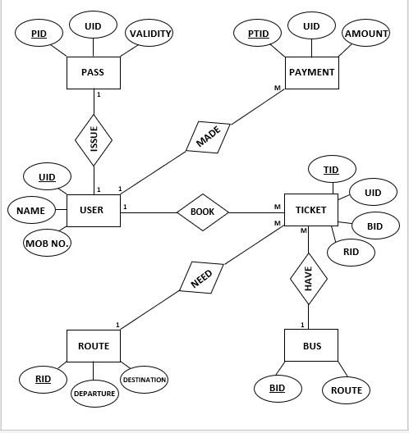

5.2 DATA FLOW DIAGRAM

A Data Flow Diagram (DFD) is a graphical representation of the ﬂow of data within a system or process. It illustrates how data is input, processed, stored, and outputted. DFDs are commonly used in systems analysis and design to understand and communicate the data ﬂow and processes involved in a system.

**Context Level DFD:**

● A Context Level Data Flow Diagram (DFD), also known as a Level 0 DFD. ● It provides an overview of the entire system or process being modeled.

● It illustrates the interactions between the system and external entities, without going into the internal details of the system.

**First Level DFD:**

● The Level 1 Diagram further decomposes each major process from the Level 0 Diagram into sub-processes or subprocesses.

● It provides a more detailed view of the system's functionality and the data ﬂows between the processes.

● The Level 1 Diagram may also show data stores where data is stored temporarily or permanently.

CONTEXT LEVEL DFD(0th LEVEL)

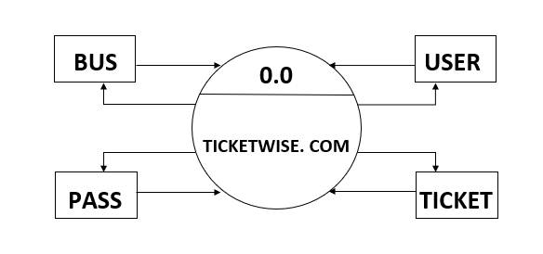

➢ DFD LEVEL 1: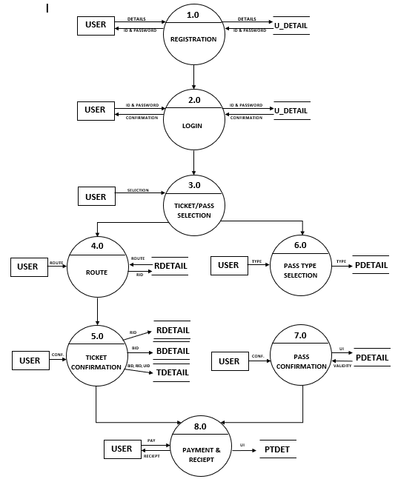

6.SCREENSHOTS

1)HOME PAGE

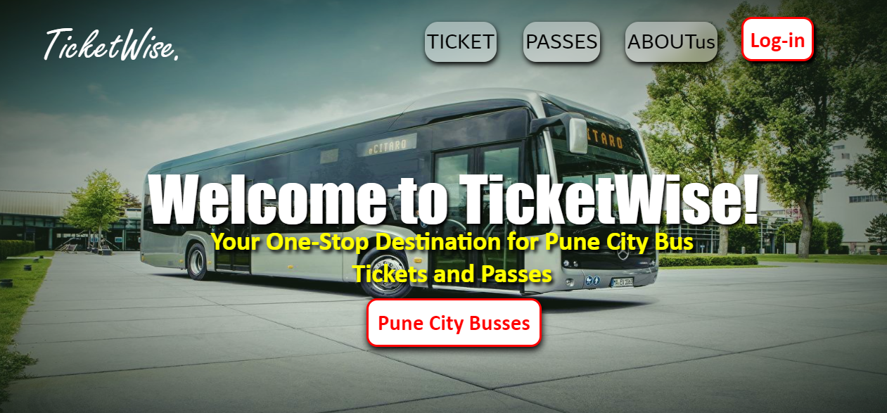

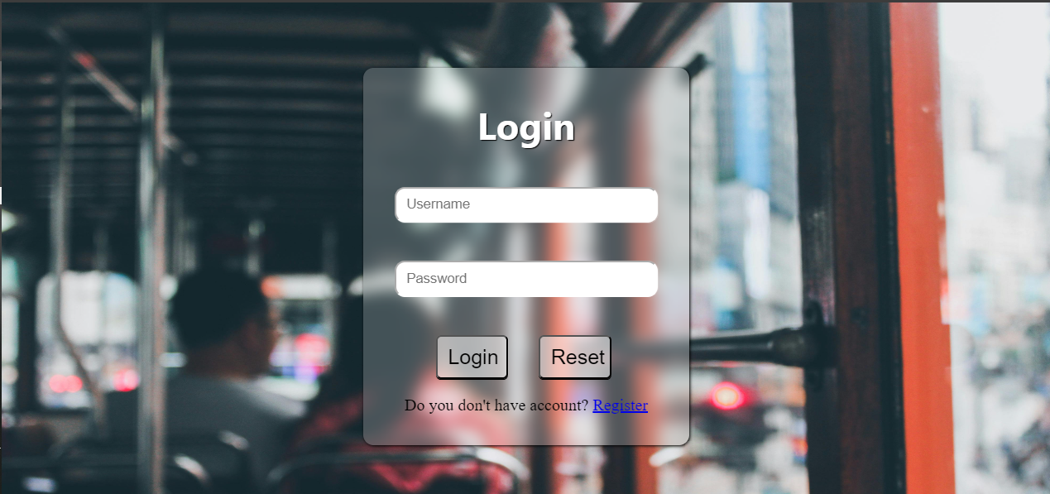

2)LOGIN PAGE

3)TICKET PAGE

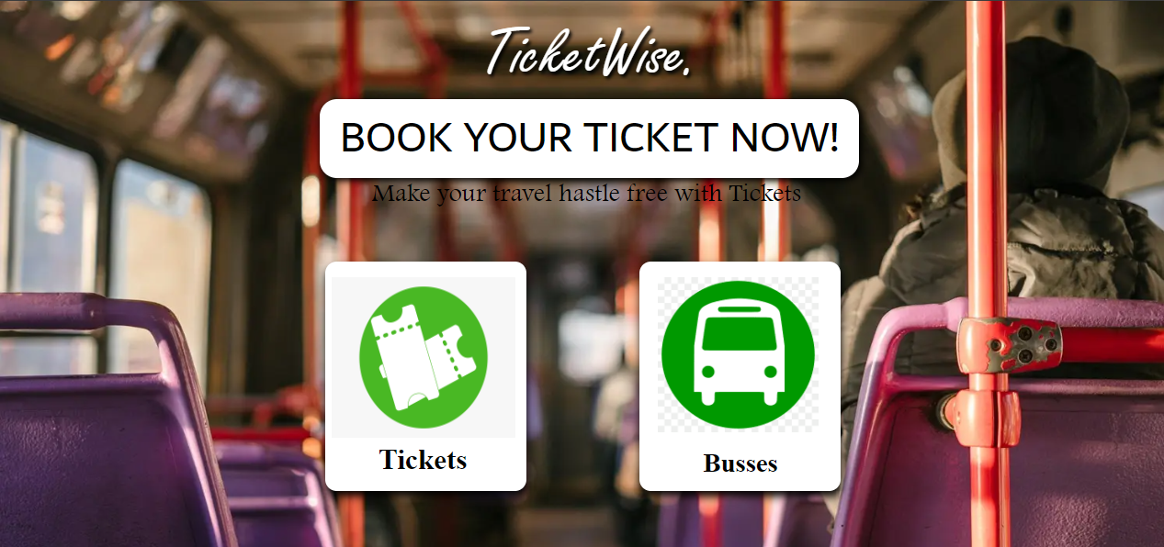

4)PASS PAGE

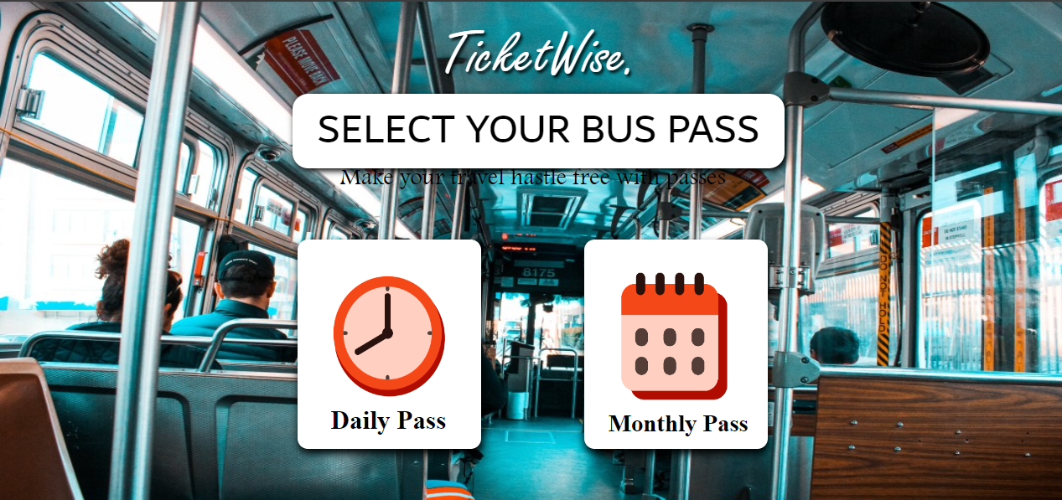

5)TICKETING

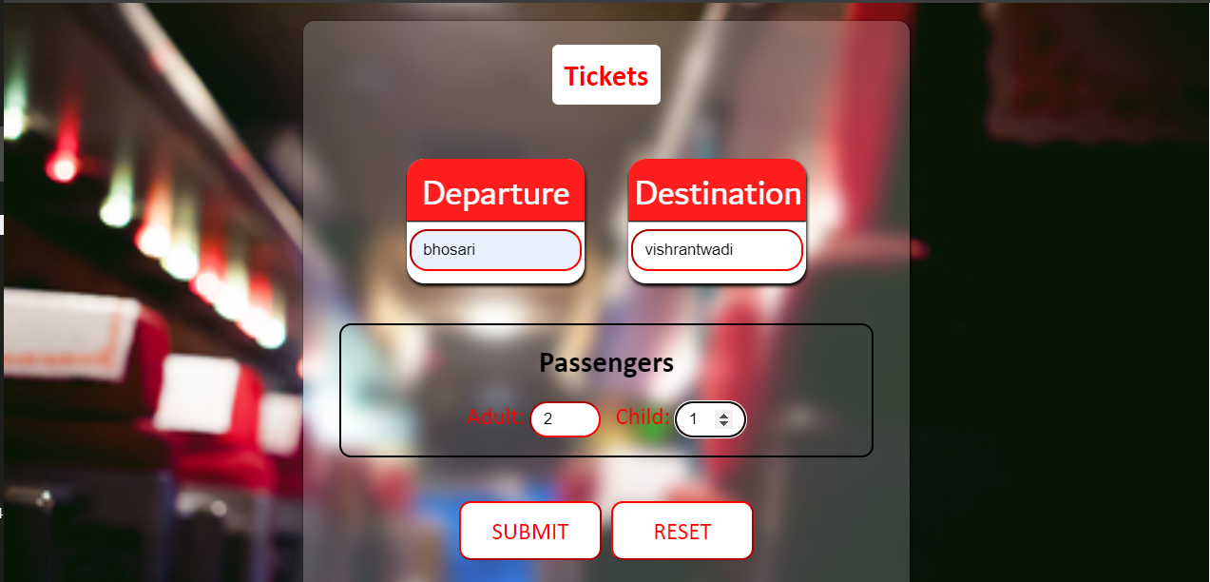

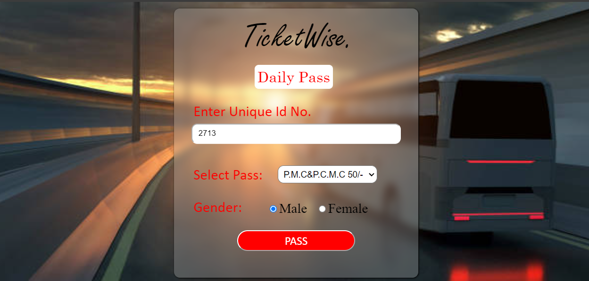

6)PASSING

7)TICKET PAY

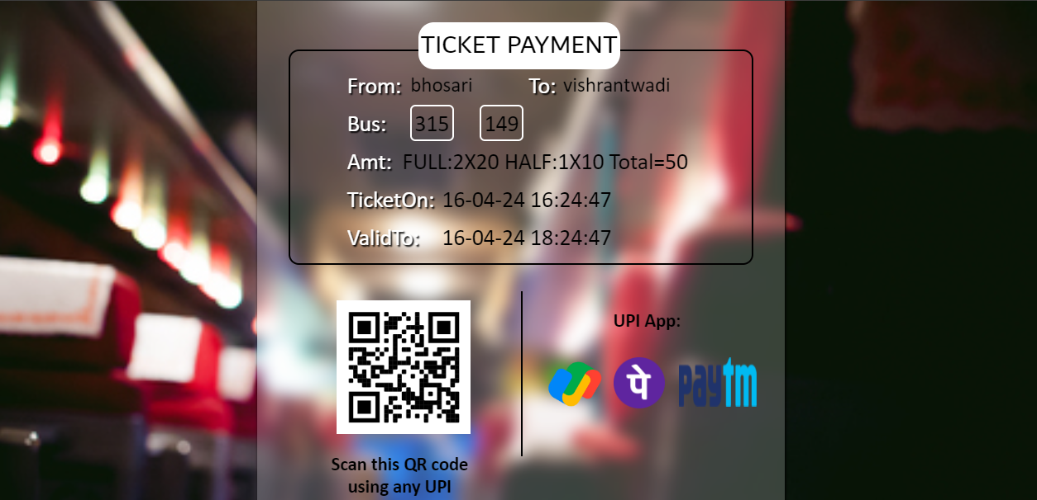

8)PASS PAY

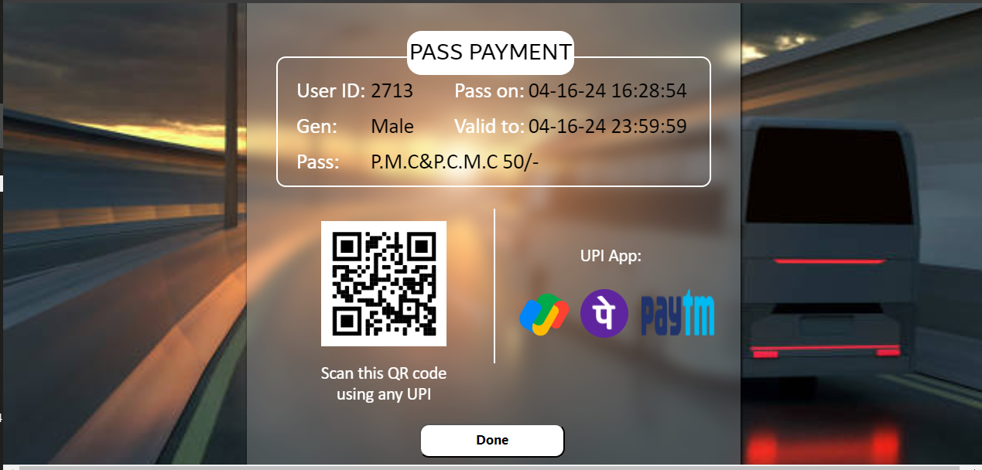

9)TICKET

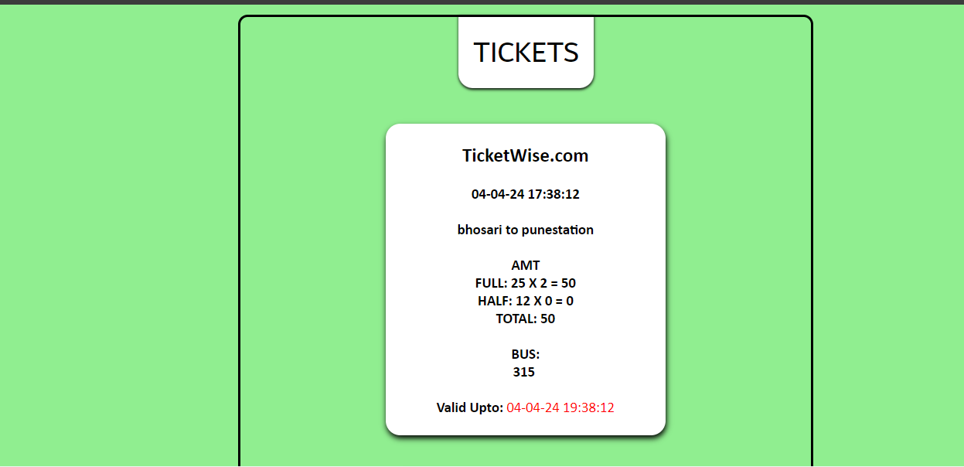

10)PASS

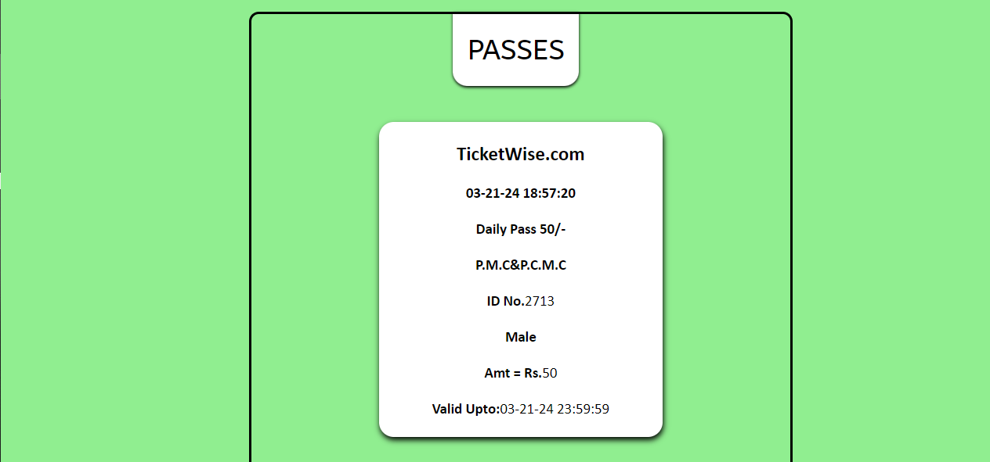

11)ABOUT US

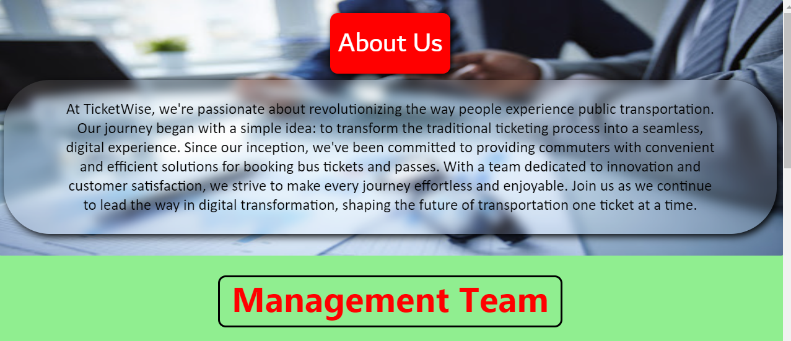

12)CONTACT

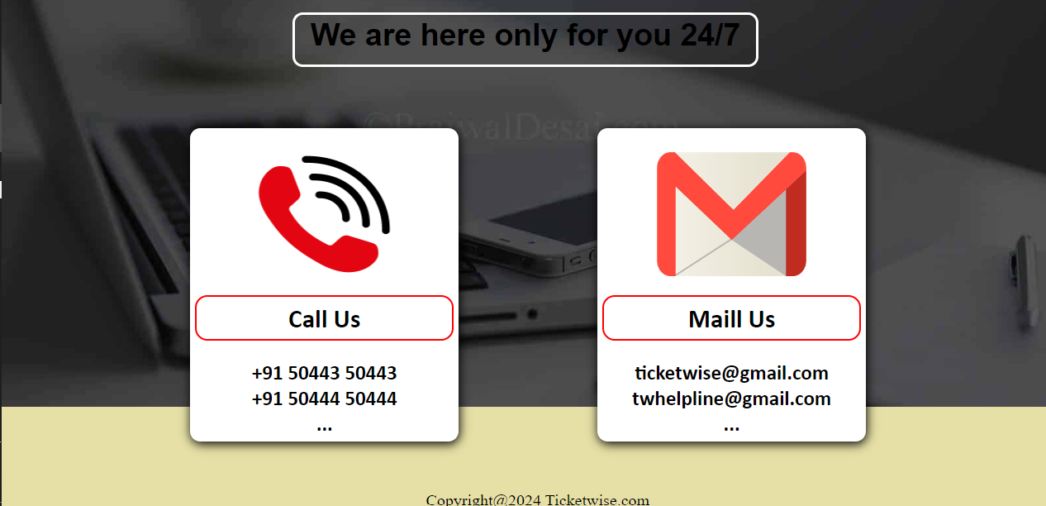

7.BIBLIOGRAPHY

❖ Using Open AI’s API

❖ Website: [https://openai.c](https://openai.com)om

❖ Learning JavaScript,HTML,CSS ❖ Website: [https://youtube.co](https://youtube.com)[m](https://www.youtube.com/)

❖ For Images

❖ Website: <https://nicepage.com>